WebUtil Implementation Guide

Contents

1 What is “WebUtil”? 3

2 Installing WebUtil 4

1. What is “WebUtil”?

WebUtill provides way of transferring files between the Client PC and the Application/Database Server via Oracle Web Forms.

The core features of WebUtil are :-

* **Text_IO**
  + Read and write text files on the client machine
* **Tool_Env**
  + Read client side variables
* **C API on the client**
  + Interface with client side C.
* **Host**
  + Run Host commands on the client machine
* **OLE2**
  + Integrate with client side OLE (e.g. Word and Excel)
* **Enhanced Host commands**
  + Host command can now call back into Forms!
* **Browser functions**
  + Integrate with the browser.
* **File transfer**
  + Move from between the client, application server and database.
* **File Manipulation**
  + Manipulate client side files.
* **Client machine information**
  + Read information from the client machine
* **READ/WRITE_IMAGE_FILE**
  + Read and write client side images
* **Get_File_Name**
  + Use a file selection dialog on the client machine
* **D2KWUtil features**
  + Client side interface into the D2KWUtil package.

There is a great deal of documentation on WebUtil on the Oracle Website. The aim of this document is to provide a relatively simplistic approach to deloying WebUtil on the Application Server.

<http://www.oracle.com/technology/products/forms/htdocs/webutil/webutil.htm>

1. Installing WebUtil

If you've selected the Complete installation option for installing Oracle Developer Suite 10g (10.1.2), WebUtil is installed and configured for you.

If you've downloaded WebUtil to install into a previous version of Oracle Forms, or to upgrade an earlier version of WebUtil, read the Webutil Release Notes document that is part of this distribution.

You can also read the Webutil Release Notes at <http://www.oracle.com/technology/products/forms/>.

The current version of WebUtil is 1.0.6. It can be configured with Oracle AS 10g (9.0.4) as well as Oracle AS 10g (10.1.2).

* 1. Prerequisites

In order to use WebUtil there are several version prerequisites:

Oracle Forms Version: WebUtil is designed to run with Oracle Forms 10g (9.0.4) and Oracle Forms 10g (10.1.2).

No testing has been done with previous versions.

Client Java Virtual Machine (JVM): WebUtil requires either JInitiator 1.3.1.13 and higher, or the Sun Java Plug-in Version 1.4.2 or higher. WebUtil uses certain Java 1.3 features that are not available in earlier versions of the JVM.

UNIX and Linux directory permissions: WebUtil downloads install.syslib libraries mentioned in webutil.cfg into the bin directory of the JRE or JVM. The client needs write permission in that particular directory.

For more information about supported plug-ins, see the latest certification matrix, Oracle Forms 10g: Client Platform Support Statement of Direction at <http://www.oracle.com/technology/products/forms/> .

Oracle Application Server Java Virtual Machine – For its Java operations on the middle tier, WebUtil needs a JVM of version 1.2.2 or higher. The JVMs supplied with Oracle Developer Suite 10g (10.1.2), Oracle Developer Suite 10g (9.0.4), Oracle Application Server 10g (10.1.2), and Oracle Application Server 10g (9.0.4) are ideal.

Oracle Database Version – The file transfer facilities within WebUtil that post and get files from the database need to be installed into a 9.0.1 database or higher. Using WebUtil against an older database will mean that this type of file transfer is not available to you.

* 1. Installation – Application Server

To install WebUtil onto an Application Server extract this ZIP file into the Oracle Forms home – i.e.

**Forms 9 - C:\product\AS.9.0.4\AS_Mid_Tier\forms90**

**Forms 10 - C:\oracle\product\AS_Mid_Tier\forms**



Doing so will affect the following folders/files :-

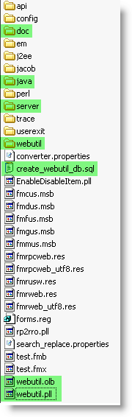

At runtime the primary components used for WebUtil are the frmwebutil.jar file and webutil.pll.

Some features of WebUtil such as OLE integration also require extra operating system libraries, which will be downloaded to the client on demand such as the jacob.dll and jacob.jar files for OLE integration.

These operating system-specific files are then stored in the **forms/webutil** and **forms/java** directories, respectively.

The Jacob libraries are attached here and need to be unzipped into the following folders:-



Java –

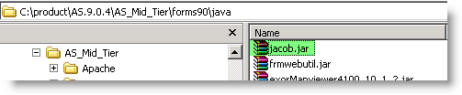

DLL –

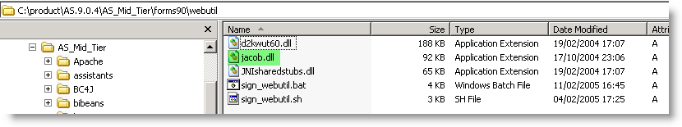

* 1. Digital Signing

You need to sign both **frmwebutil.jar** and **jacob.jar** with the same digital certificate.

This is a one-time operation which allows your end-users to trust that the JACOB routines can access client side resources.

If you do not have an existing signing certificate, or if you are not sure how to sign Jar files, a script is in the forms\WebUtil directory to help you.

This script is called **sign_webutil.sh** for UNIX and **sign_webutil.bat** for Windows.

To sign the Jar files:

• Open a Command window and change to the **ORACLE_HOME\forms\webutil** directory.

• Check that **ORACLE_HOME/jdk/bin** is in the path. If it is not, add it.

• In Windows, Issue **sign_webutil.bat** **ORACLE_HOME\forms\java\frmwebutil.jar** (or the path to where you installed WebUtil). On UNIX, issue **sign_webutil.sh**

**ORACLE_HOME/forms/java/frmwebutil.jar** (or the path to where you installed WebUtil).

• In Windows, Issue **sign_webutil.bat** **ORACLE_HOME\forms\webutil\jacob.jar**. In Unix, issue **sign_webutil.sh** **$ORACLE_HOME>\forms\java\jacob.jar**.

* 1. Configure HTTP Server

WebUtil needs a single virtual directory to be defined in order to download files at runtime as they are needed. You will need to create a virtual directory called

**j2ee/DevSuite/application-deployments/forms/formsweb/webutil**

which maps onto the **ORACLE_HOME/forms/webutil** directory in the Oracle Developer Suite and Oracle Application Server ORACLE_HOME directories.

In Oracle Application Server, define the same virtual directory in the forms/server/forms.conf file:-

**AliasMatch ^/forms/webutil/(..*) $ORACLE_HOME/forms/webutil/$1"**

i.e.

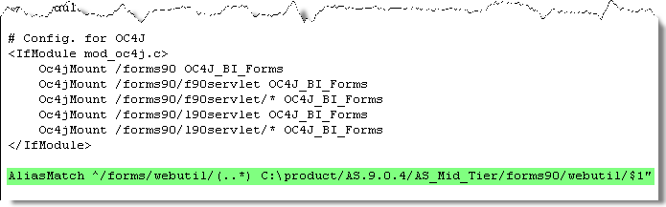

* 1. Configure FORMSWEB.CFG File

You need to define the location of the WebUtil.jar file :–

**webUtilArchive=frmwebutil.jar**

You need to define the default HTML templates to use with JINIT/JRE :-

**baseHTMLjinitiator=webutiljini.htm**

You also need to define the location of the Jacob JAR file :-

**webUtilArchive=jacob.jar**

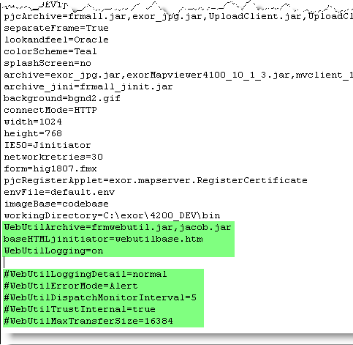

Please don’t enable the commented out (#) options unless you really need to – they will raise messages through the forms. These are particularily useful for debugging problems.

You don’t really need to enable the WebUtilLogging either unless you really want a trace of all connections etc.

* 1. Configure DEFAULT.ENV file

The default.env file on the App Server requires the following info adding (usually stored in **/forms/server** ) :-

**WEBUTIL_CONFIG=ORACLE_HOME\forms\server\webutil.cfg**

**CLASSPATH=\ORACLE_HOME\forms\java\frmwebutil.jar;c:\ids9i\jdk\jre\lib\rt.jar**

i.e.

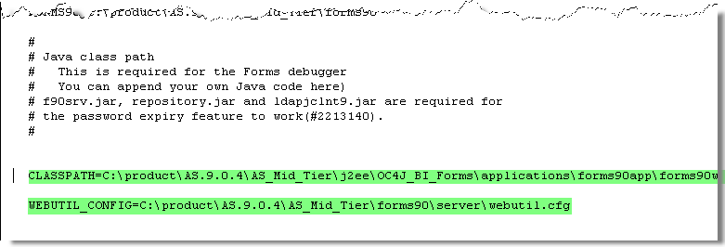

* 1. Securing WebUtil

The Oracle documentation covers the security side of WebUtil – too much to go into here!

<http://www.oracle.com/webapps/online-help/forms/10g/state/content/navId.3/navSetId._/vtTopicFile.web_util|install~htm/>

* 1. Configuring webutil.cfg

There are numerous options that can be configured in webutil.cfg relating to Logging, OS specifics, Upload/Download, Work areas all of which are documented here in detail :

<http://www.oracle.com/webapps/online-help/forms/10g/state/content/navId.3/navSetId._/vtTopicFile.web_util|config~htm/>

We are only really interested in getting the File Transfer working to start with, and this requires the following change to webutil.cfg (stored under **forms/server**)

